Assignment 6

Sachin Shubham

3/13/2021

1 Task One aspect of wildlife science is the study of how various habits of wildlife are affected by environmental conditions. In this exercise, we are concerned about the effect of air temperature on the time that the ”lesser snow geese” leave their overnight roost sites to fly to their feeding areas. The data is given in Geese.txt.

1. Obtain the necessary plots.
2. Compute the LM coefficients for the ’time vs temp’ model (β0 , β1).
3. Obtain the regression equation.
4. Obtain the confidence intervals for β1.
5. Is there correlation between the temperature and time in the Geese data set?

Solution:

filepath = 'C:\\Users\\sachi\\Downloads\\Geese.txt'  
  
  
geese <- read.table(filepath, # TXT data file indicated as string or full path to the file  
 header = TRUE, # Whether to display the header (TRUE) or not (FALSE)  
 sep = "", # Separator of the columns of the file  
 dec = ".") # Character used to separate decimals of the numbers in the file  
  
# PREDICTOR (temprature)  
temp<-geese$temp  
  
# RESPONCE (time)  
time<-geese$time  
  
# Apply the lm() function.  
model = lm(temp ~ time, data = data.frame(geese) )  
  
#1 Plot  
# Plot the chart.  
plot(time,temp,col = "blue",main = "Effect of Air Temperature on Lesser Snow Geese Leaving Roost",  
 abline(lm(temp~time)), cex = 1.3, pch = 16,  
 xlab = "Air Temperature",  
 ylab = "Lesser Snow Geese Response Time")

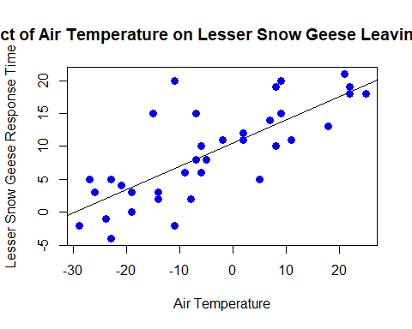

par(mfrow = c(2, 2))  
plot(model)

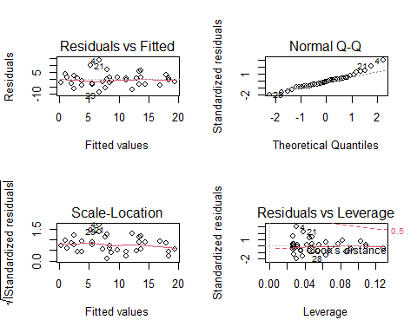

#2 LM coefficients for the ’time vs temp’ model (β0 , β1)  
lm(formula = time ~ temp, data = geese)

##   
## Call:  
## lm(formula = time ~ temp, data = geese)  
##   
## Coefficients:  
## (Intercept) temp   
## -19.667 1.681

#3 The regression equation  
lm(temp ~ time, data = data.frame(geese))

##   
## Call:  
## lm(formula = temp ~ time, data = data.frame(geese))  
##   
## Coefficients:  
## (Intercept) time   
## 10.5137 0.3523

#4 Confidence intervals for β1  
confint(model, 'time', level=0.95)

## 2.5 % 97.5 %  
## time 0.2534182 0.4511043

#5 Is there correlation between the temperature and time in the Geese data set?  
correlation_coeff<-cor(time,temp)  
correlation_coeff

## [1] 0.7694334

print(summary(model))

##   
## Call:  
## lm(formula = temp ~ time, data = data.frame(geese))  
##   
## Residuals:  
## Min 1Q Median 3Q Max   
## -8.6388 -2.9401 -0.2408 1.6338 13.3612   
##   
## Coefficients:  
## Estimate Std. Error t value Pr(>|t|)   
## (Intercept) 10.51370 0.77714 13.529 1.10e-15 ***  
## time 0.35226 0.04874 7.228 1.65e-08 ***  
## ---  
## Signif. codes: 0 '***' 0.001 '**' 0.01 '*' 0.05 '.' 0.1 ' ' 1  
##   
## Residual standard error: 4.559 on 36 degrees of freedom  
## Multiple R-squared: 0.592, Adjusted R-squared: 0.5807   
## F-statistic: 52.24 on 1 and 36 DF, p-value: 1.653e-08

Our study shows that Multiple R-squared is approx 60%(0.592) and p-value is 1.653e-08.

The 0.7694334 Correlation Coefficient indicate a strong positive linear relationship.

The fitted β1 is 0.35226 with an interval of (0.2534182, 0.4511043).

As p-value(1.653e-08) is less than 0.05, therefore relationship between time and temperature is statistically significant.It indicates strong evidence against the null hypothesis, as there is less than a 5% probability the null is correct. Therefore, we reject the null hypothesis, and accept the alternative hypothesis.